Pre-Clinical Research

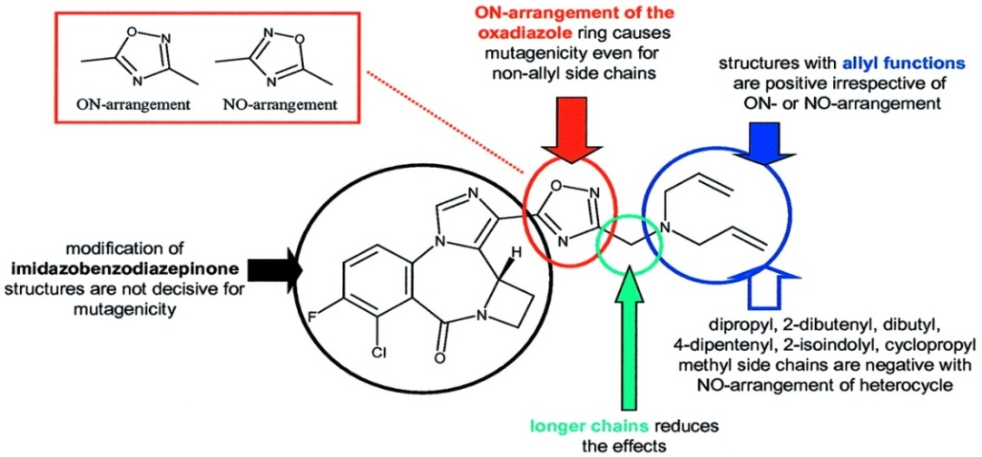

Identify structure-activity relationships (SARs).

Identify the pharmacophore.

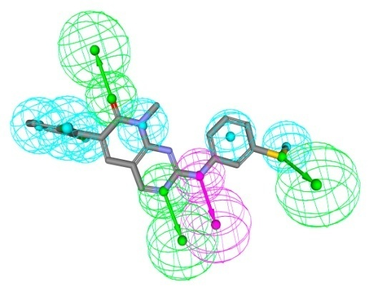Once a lead has been discovered, it is important to understand precisely which structural features are responsible for its biological activity (i.e. to identify the “pharmacophore”)

***In vivo testing***

Lead compounds are tested in vivo for safety and efficacy, in laboratory animals (animal models) such as mice and rat.

Drug action (Behaviour and reaction, Physiology, Histopathology)

Toxicology (Acute toxicity, Sub-chronic toxicity, Tissue specific toxicity, Tolerability)

Consider ethical aspects (e.g. number and kind of animals used)

**Improve target interactions (pharmacodynamics)**

The study of what a drug does to the body.

Investigate: Physiological effects

Drug action

Relationship between drug concentration and effect

Improve pharmacokinetic properties

The study of what the body does to the drug.

Investigate: Liberation

Absorption

Distribution

Metabolism

Excretion

Investigational New Drug Application (IND)

An Investigational New Drug (IND) application is the documentation presented to the FDA requesting permission to study a new drug, drug formulation, new dosage form, drug combination, or new drug indication in a human clinical trial. An IND includes summaries, original data, and formal reports covering chemistry, formulation, stability data, container enclosure and storage information, manufacturing and control methods for the drug and drug formulation, specifications, preclinical pharmacology, safety and toxicology on the drug, the clinical plan, statistical plan and clinical brochure, and the required forms for filing an IND. IND becomes effective if the FDA does not disapprove it within 30 days.